**SQL Assignment 1**

* **Write a query to get a Product list (id, name, unit price) where current products cost less than $20.**

**Query**

select productID,ProductName,UnitPrice from products where UnitPrice<20;

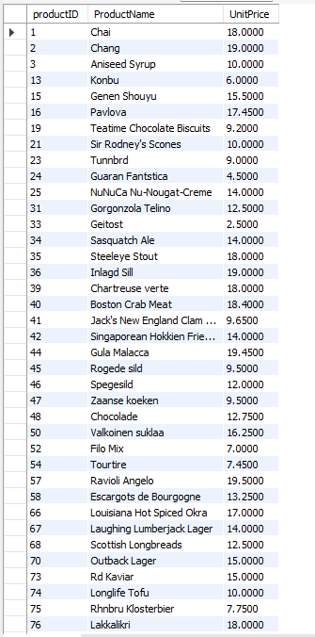

* **Write a query to get Product list (id, name, unit price) where products cost between $15 and $25.**

**Query**

select productID,ProductName,UnitPrice from products where UnitPrice between 15 and 25;

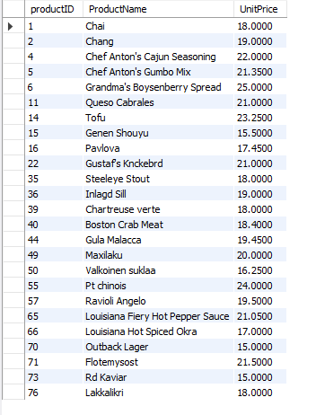

* **Write a query to get Product list (name, unit price) of above average price.**

**Query**

select ProductName,UnitPrice from products where UnitPrice>(select avg(UnitPrice) from products);

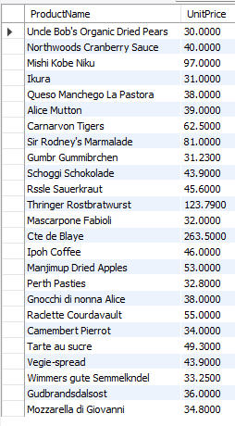

* **Write a query to get Product list (name, unit price) of ten most expensive products.**

**Query**

select ProductName,UnitPrice from products order by UnitPrice desc Limit 10;

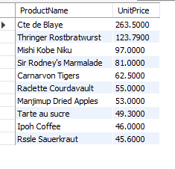

* **Write a query to count current and discontinued products.**

**Query**

select Discontinued,count(ProductId) from products group by Discontinued;

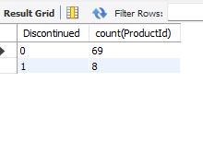

* **Write a query to get product list(name, units on order,unit in stock) of stock is less than the quantity on order.**

**Query**

select productID,UnitsInStock,UnitsOnOrder from products where UnitsInStock < UnitsOnOrder;

